1. New-AzResourceGroup `

-ResourceGroupName "myResourceGroupLoadBalancer" `

-Location "EastUS"

2. $publicIP = New-AzPublicIpAddress `

-ResourceGroupName "myResourceGroupLoadBalancer" `

-Location "EastUS" `

-AllocationMethod "Static" `

-Name "myPublicIP"

3. $frontendIP = New-AzLoadBalancerFrontendIpConfig `

-Name "myFrontEndPool" `

-PublicIpAddress $publicIP

4. $backendPool = New-AzLoadBalancerBackendAddressPoolConfig `

-Name "myBackEndPool"

5. $lb = New-AzLoadBalancer `

-ResourceGroupName "myResourceGroupLoadBalancer" `

-Name "myLoadBalancer" `

-Location "EastUS" `

-FrontendIpConfiguration $frontendIP `

-BackendAddressPool $backendPool

6. Add-AzLoadBalancerProbeConfig `

-Name "myHealthProbe" `

-LoadBalancer $lb `

-Protocol tcp `

-Port 80 `

-IntervalInSeconds 15 `

-ProbeCount 2

7. Set-AzLoadBalancer -LoadBalancer $lb

8. $probe = Get-AzLoadBalancerProbeConfig -LoadBalancer $lb -Name "myHealthProbe"

9. Add-AzLoadBalancerRuleConfig `

-Name "myLoadBalancerRule" `

-LoadBalancer $lb `

-FrontendIpConfiguration $lb.FrontendIpConfigurations[0] `

-BackendAddressPool $lb.BackendAddressPools[0] `

-Protocol Tcp `

-FrontendPort 80 `

-BackendPort 80 `

-Probe $probe

10. Set-AzLoadBalancer -LoadBalancer $lb

11. Create subnet config

$subnetConfig = New-AzVirtualNetworkSubnetConfig `

-Name "mySubnet" `

-AddressPrefix 192.168.1.0/24

12. Create the virtual network

$vnet = New-AzVirtualNetwork `

-ResourceGroupName "myResourceGroupLoadBalancer" `

-Location "EastUS" `

-Name "myVnet" `

-AddressPrefix 192.168.0.0/16 `

-Subnet $subnetConfig

13. for ($i=1; $i -le 3; $i++)

{

New-AzNetworkInterface `

-ResourceGroupName "myResourceGroupLoadBalancer" `

-Name myVM$i `

-Location "EastUS" `

-Subnet $vnet.Subnets[0] `

-LoadBalancerBackendAddressPool $lb.BackendAddressPools[0]

}

14. $availabilitySet = New-AzAvailabilitySet `

-ResourceGroupName "myResourceGroupLoadBalancer" `

-Name "myAvailabilitySet" `

-Location "EastUS" `

-Sku aligned `

-PlatformFaultDomainCount 2 `

-PlatformUpdateDomainCount 2

15. $cred = Get-Credential

//User:username

//Password:pass

16. for ($i=1; $i -le 3; $i++)

{

New-AzVm `

-ResourceGroupName "myResourceGroupLoadBalancer" `

-Name "myVM$i" `

-Location "East US" `

-VirtualNetworkName "myVnet" `

-SubnetName "mySubnet" `

-SecurityGroupName "myNetworkSecurityGroup" `

-OpenPorts 80 `

-AvailabilitySetName "myAvailabilitySet" `

-Credential $cred `

}

17. for ($i=1; $i -le 3; $i++)

{

Set-AzVMExtension `

-ResourceGroupName "myResourceGroupLoadBalancer" `

-ExtensionName "IIS" `

-VMName myVM$i `

-Publisher Microsoft.Compute `

-ExtensionType CustomScriptExtension `

-TypeHandlerVersion 1.8 `

-SettingString '{"commandToExecute":"powershell Add-WindowsFeature Web-Server; powershell Add-Content -Path \"C:\\inetpub\\wwwroot\\Default.htm\" -Value $($env:computername)"}' `

-Location EastUS

}

18. Get-AzPublicIPAddress `

-ResourceGroupName "myResourceGroupLoadBalancer" `

-Name "myPublicIP" | select IpAddress

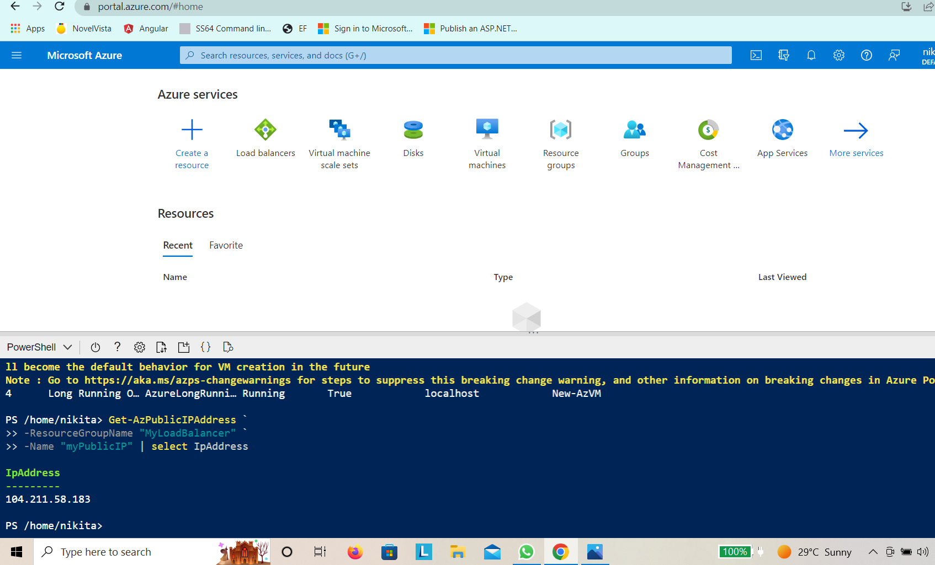

Output:

